On Prolonging One's Life Span

Background

It's 1279. We don’t know exactly when but probably in Spring, several months before October 12th when the Daishonin inscribed the Dai-Gohonzon. Nichiren wrote this letter to Myojo, lay nun and the wife of Toki Jonin. Myojo married Toki after the death of her first husband. Her son by the first marriage later took the name Nitcho and became one of the six elder priests of the Daishonin. Myojo had a second son by Toki Jonin who also became a disciple and priest. Myojo and Toki are retainers to Lord Chiba, the Constable of Somosa Province, so fairly important people in their own right.

There is epidemic ill-health throughout Japan and it has caused concern among Nichiren's followers. In 1278 the Daishonin wrote "The Treatment of Illness" to Toki Jonin who may well have been asking because of Myojo's ill health. In fact, it appears from "The Bow and Arrow" gosho that she had been ill from as early as 1276, possibly from the effort of nursing Toki Jonin's mother through a long illness ending in her death earlier that year. We can speculate that it may have been something similar to the diarrohea which Nichiren himself suffered from for several months. We often forget, in this day of saline drips, vitamin pills, salt replacement therapy etc. that diarrohea is still a killer disease in third world countries, often associated with Cholera. To people in 13th Century Japan it must have been like HIV Aids - a progressive wasting condition with an uncertain prognosis but significant mortality. In fact, Aids is still usually called "Slim" in much of East Africa. And like Aids it would hve been seen, in a provisionally Buddhist culture, as punishement for previous immorality.

However Myojo herself appears to have died only in 1303, 24 years after this present gosho was written.

Having set the stage, let's read the gosho.

Gosho

There are…is unfixed

Nichiren compares illness to karma, and says that "sincere repentence" will eradicate even fixed karma. Implicitly, he seems to be saying that fixed karmic illness can be cured.

The seventh volume…passing.

The necessary medicine is the Lotus Sutra, which discards expedient means and which has been confirmed by Taho and all the other Buddhas.

King Ajatashatru..dewdrops

Nichiren gives an example of karmic illness: "His death was predetermined by his fixed karma." The teaching of the Lotus Sutra, as presented in the Nirvana Sutra, and the illness and heavy karmic offences vanished entirely. Implicitly, the disease was caused by "grave offences". It was common knowledge that Ajatashatru was pursuaded by Devadatta to kill his own father, Bimbisara, a follower of Shakyamuni. and to persecute Buddhists in Maghada.

More than fifteen…Lotus Sutra

The Daishonin gives further examples of fixed karma, people who prolonged their lives by virtue of faith in the Lotus Sutra, and advises (a) steadfast faith "to see what it will do for you" and to see Shijo Kingo.

Life is the most…your illness

Nichiren extolls the value of life, and says that the aspect of life span is what makes the Lotus Sutra superior to all others, while wisdom will not compensate for a short life.

I could ask…values his friends

Nichiren tells Myojo to see Shijo herself rather than through the Daishonin. He suggests she will have nothing to lose because Shijo knows about it and would like to help. He also mentions concern because of the length of the illness.

If you are unwilling…those gods.

Nichiren says willingness is crucial, and this requires sincere faith. Again, he repeats that the longer a person who takes faith in the Sutra lives, the greater their benefit. (However from a letter to Shijo Kingo we also know that a long life without honour is worthless.) He concludes by saying that he will pray to the Shoten Zenjin (Nitten and Gatten) for her.

Key elements
The Daishonin writes to Myojo because she is ill, to explain that illness can be karmic in origin, and either serious or not so, fixed or changeable.

Illness: Severe or minor, some related to karma as in the example of King Ajatashatru's slander and repentence. In "Four Kinds of Illness", the Daishonin says that he thought his own illness was fixed karma, i.e. fatal, but he had received effective medical remedy so it must have been changeable karma.

Slander: Ultimately, disrespect for Buddha nature. The word never appears in this gosho, but obviously Ajatashatru's grave condition is the result of slander of the Law. Slander is a routine occurrence, but severe slander creates firmly-entrenched negative causes.

The 14 Slanders

If we look at the 14 Slanders the list seems varied. But they have a common root – “they all represent short cuts which allow people to tell themselves that they are right, and that any faults and problems lie with others.” (Nick Rowntree, UKE June ’94) This is effectively denying our own and other people's buddha nature, slandering our own gohonzon.

So “Bodhisattva Fukyo of old said that all peple have the Buddha nature…You can surmise the significance of the 14 slanders in the light of the above quotation.” (14 Slanders).

Slander is not objective or clearly visible - the same words may produce different consequences in different circumstances. Truth is not a defence, and the consequences may not be known at the time but are still our responsibility.

Karma: Action and the consequences of volitional acts, held as latent causes which may manifest for better or worse when the right circumstances take place.

Nichiren divides karma into two categories: mutable and immutable, or fixed and changeable. Both may be either good or bad.

Mutable karma: weaker influence and can be overcome through willpower.

Immutable karma: more deeply rooted, harder to change and is the determining force of the basic direction in our lives.

"According to the Kusha Ron of Vasubandhu, there are four causes which created immutable karma: (1) earthly desires arising from the fundamental darkness innate in life; (2) a pure, seeking mind toward Buddhism; (3) daily routine; and (4) Buddhist or secular sins such as killing a Buddhist, one's parents, etc. Shakyamuni's Buddhism takes a somewhat simplistic view of causality: If one is a thief in this lifetime, he will be reborn poor in the next; if he deprecates someone who is handsome, he will be reborn ugly, and so on. Nichiren Daishonin's Buddhism teaches that the deepest causes are one's support or slander of the Mystic Law.
"These causes lie deep within one's life, beyond the ability to sense or conceive. However, "On Prolonging One's Life Span" positively asserts that strong faith in and apology to the Gohonzon can change even immutable karma. In this instance, the Daishonin is using the natural life span of a person as an example of immutable karma. By asserting that chanting Nam-myoho-renge-kyo can change such karma, he is saying that the unchangeable is affected by prayer to the Gohonzon. "

Karma is symmetrical - it cannot be more difficult to create good causes than bad ones if we can overcome our delusions in order to take the right actions in the first place.

Karma relates to fundamental life state: good causes improve our basic life state, but that takes a prolonged and consistent effort – “just single-mindedly chant Nam Myoho Renge Kyo morning and evening, day and night, and observe what happens at the moment of your death” (Reply to Lord Matsuno). The moment of your death is when, in Buddhist tradition, we determine and can see our fundamental lifestate.

Similarly, if we fail to practice diligently it will be impossible to keep pace with the slander which is routinely part of life. Killing an ant is slanderous. Being rude to someone who carves you up in traffic is slanderous. And Nichiren points out that fixed karma, usually from previous lifetimes, cannot be avoided at all! So without consistent practice, which is faith in the Mystic Law, we will always be feeding the roots of negativity in our lives.

We cannot turn karma on an off like a light bulb. We can stop creating negative causes and start creating positive ones, and we can expiate the causes already made by dragging them into view. This is like improving your flower garden - we stop weed seeds from getting in and start planting flowers and bulbs. Then we weed diligently to pull up the brambles and bindweed right now, while they're small. And we use a serious weedkiller to help us kill the big ones we allowed to get a foothold last year. Nichiren tells Toki's wife that his weedkiller for the Latter Day of the Law works on ancient brambles that nothing else can touch. (Well, not in so many words!)

Fixed and Unfixed Karma

Dick Causton in The Buddha in Daily Life clearly describes mutable and immutable karma.
" It is not unknown for hardened criminals to reform and become artists, social workers or priests, for example, nor for respected figures in society to become corrupted and ignoble. Thus if we meet the right external cause and make the right choices, even fundamental, deep-seated karma can be changed; although we must at some point inevitably experience the bad effects of bad causes we have made in the past - either in this or previous lifetimes - our actions now can alter and lighten how those effects appear.
"Buddhism teaches that there are basically two kinds of karma: the mutable, or changeable, and the immutable. Generally speaking, immutable karma produces a fixed effect at a specific time, while the effects of mutable karma cannot be specified either in terms of how or when they will appcar. Death is an example of immutable karma: it is inherent in life, and although it can be delayed, ultimately it cannot be prevented by any of our actions. Similarly, if we have the karma to suffer an incurable disease, nothing we do can stop this disease from appearing in our life if the time is right for it to appear. Habitual acts, consistently repeated, also form immutable karma in the form of equally consistent effects. "
And to remind ourselves, karma is volitional action. Everyone remembers, I'm sure, Mr. Causton's diagram of the Nine Consciousnesses.
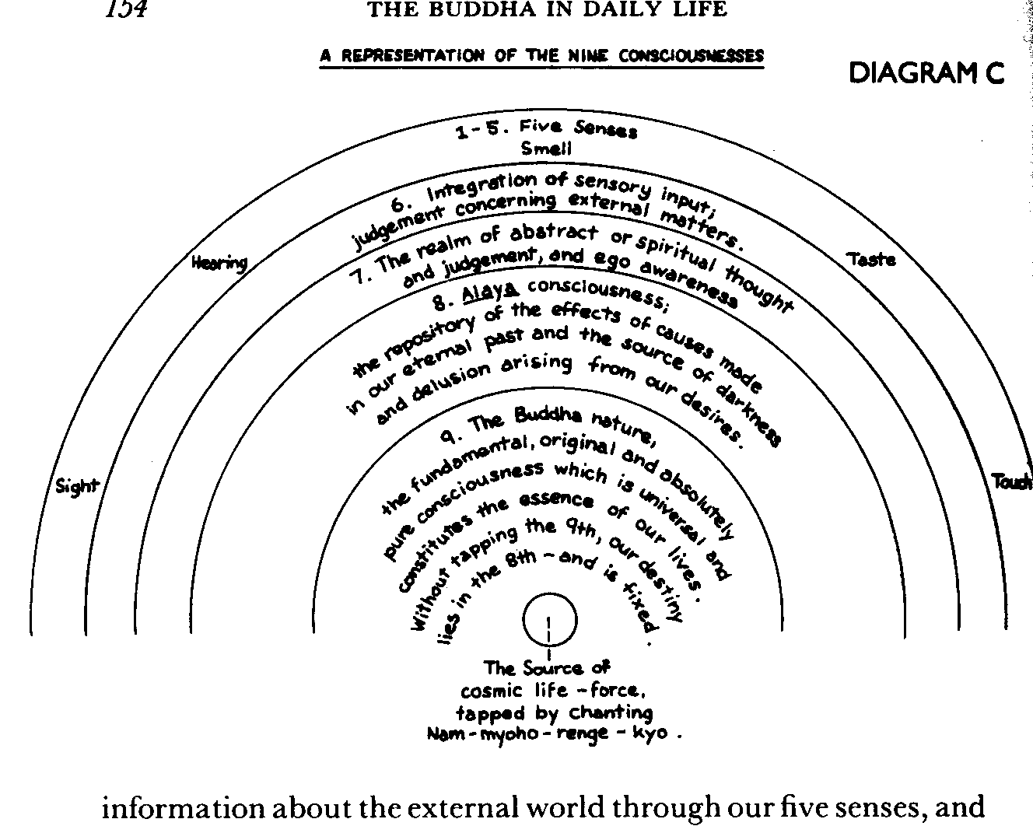

Karma is formed in the 6 consciousnesses, but it resides in the 8th. Which means that abstract rationality in the 7th consciousness can be directly affected by karma, but cannot directly inflence it. All this is well-described in Basics of Buddhism and Buddha in Daily Life.
Karma may manifest as illness. In "On Curing Karmic Disease" Nichiren quotes the Nirvana Sutra's description of 3 causes of karmic disease:
“There are three types of people whose illness is extremely difficult to cure. The first is those who slander the Great Vehicle; the second, those who commit the five cardinal sins; and the third, icchantikas, or persons of incorrigible disbelief.”
In other words, the opposite of the Three Truths or the three aspects of Faith. Another interesting way to view it is as being Unwilling to acknowledge the Law, Unwilling to Accept and Understand it and Unwilling to Act in accordance with it. This is the opposite of Myo, wich is Awakening, Wisdom and Life Force.
Here's a Visial Aid to illustrate the point.

Relationship Between Different Types of Karmic Illness and Positive Aspects of Faith

Karmic Illness Type or Cause | Affects | Affected Aspect of Faith | 3 Enlightened Properties & 3 Virtues | Three Obvious Truths (Santai) | Buddhist Apology (Sange) | 12th Step
Slander the Great Vehicle | Spiritual  Ego blocks buddha mind:  Loss of integrity, loss of faith, | Sraddah  (Awakening, Willingness) | Nyo ze tai  Entity, Law  The "Dharma Body" | Truth of the Middle Way (Chutai) | Appreciation, gratitude, willingness | Having had a spiritual awakening as the result of these steps,
Incorrigible disbelief (icchantikas) | Mental  Psychological Issues - ego, habituation, denial, rationalisation, projection | Adhimukti  ("Belief and Understanding", Acceptance) | Nyo ze sho  Nature, Wisdom  The "Reward Body" | Truth of Non-substantiality  (Inter-dependent Origination, Renge, Kutai) | Self-Realization, Apology, prayer for others | …we tried to carry this message to other alcoholics
Commit one of the five cardinal sins | Physical  Clinical Illness or addiction, physical craving | Prasada  ("Pure Faith", Human Revolution) | Nyo ze ho  Appearance, Action, Freedom  The "Manifest Body" | Truth of Non-permanence  (Temporary Existence, Myoho, Ketai) | Determination, rectification | …and to practice these principles in all our affairs.

This shows how the formation of negative karma is linked to the absence of an aspect of positive faith.
Each cause-type of karmic illness compromises an essential aspect of faith.
This does not mean that illness characterizes someone as evil. The Daishonin says in the same gosho that expiating evil karma can cause illness in this life instead of hell in future, "Thus illness occurs when evil karma is about to be dissipated".
Similarly, "From illness arises the mind that seeks the way." (MW5 p.280) However it arises, "the Nirvana Sutra, referring to the Lotus Sutra, states: "Even the offense of slandering this correct teaching [will be eradicated] if one repents and professes faith in the correct teaching," (WND 632) and “”if one experiences extreme hardship in this life [because of the Lotus Sutra] the sufferings of hell will vanish instantly.” (Lessening One’s Karmic Retribution)
Fixed karma is really one's fundamental life state. For example, we might think that harming someone would not seriously change one's life state, but the consequences of an action may be serious or trivial depending on other factors unknown to us at the time. This is the working of conditionality, of dependant origination. An exceptional act in this lifetime may be one of a series in several lifetimes, or the culmination of a progressive manifestation of a profound condition.
Prior to the Lotus Sutra, fixed karma was considered not so much unalterable as unexpiable in this lifetime. For example, the karma to be a woman or a person of the Two Vehicles could be changed over successive lifetimes. So it may be more accurate to say that only with the Lotus Sutra, the Buddhism of the Sowing, is it possible to expiate grave offences in a single lifetime, by fusing our life with the Law:
"The Yuga-ron of Bodhisattva Maitreya and the Dairon of Bodhisattva Nagarjuna both state that if one's illness is caused by immutable karma, even the most excellent medicine will turn to poison, but if he believes in the Lotus Sutra, poison will change into medicine. (from General Stone Tiger)"
and
Wherever he may be, whether in the mountains, on the seas, in the skies or in the cities, man cannot escape death. However, a passage from one of the sutras explains that even one's immutable karma can be changed. T'ien-t'ai interprets this passage to mean that one can prolong his fixed span of life. ("Propagation by the Wise")
"Changeable" then does not mean "free". It is not sufficient to think cheery thoughts to the Gohonzon for a few minutes to challenge a seriously slanderous lifestate.

Who Knows

Personally, if I see a gosho called "On Prolonging One's Life Span" I want to know how it's going to prolong mine. What's the secret? How do we do it? How is this gosho going to change our lives? Isn’t that why we're willing to practice Buddhism and travel to Study Lectures etc.? Because we want to change our lives?

Before we go further, can I have a show of hands for two questions?
- Who has personal experience of fixed karma?
- Did you manage to conclusively change it?

How do we expiate fixed karma?
The short answer is that we experience karma, whether happy or unhappy, as the manifest effect of latent causes. This is the 10 factors in the Hoben chapter, basis of Tien T'ai's doctrine of ichinen sanzen. Negative causes are those based on our delusions and refusal to accept our buddha nature. In other words, we experience the Ho of our causes but cannot see the Myo underlying them. We become ensnared in transient phenomena, Tenji-ma, and prey to evil and destructive influences which Nichiren calls devils and demons.
To expiate the causes we made, we need to reawaken to our budha-hood, which allows us to stop slandering the Law and move the effects of our previous actions into a positive lifestate. This requires not only willingness and understanding, but also action:
“One of the six stages of practice in the perfect teaching is the stage of perception and action. At this stage ‘one acts as one speaks and speaks as one acts.’ Those at the stage of being a Buddha in theory only …believe in the perfect teaching, but even though they praise it, their actions fail to reflect their words.” (Lessening One’s Karmic Retribution)
I might stop being angry (having Anger as my dominant lifestate) and the causes I made while in an Anger state are now manifesting in a Bodhisattva state. So instead of being killed in a pub brawl, I find myself arguing passionately against bombing in Afghanistan.
But to change our life state is like changing a habitual way of thinking or acting. For example, a suicide bomber is someone who views himself as a victim, someone powerless to right the overwhelming injustice done to him and therefore someone with nothing to lose by dying. The slander is to habitually think of oneself as a victim and act accordingly. Changing that requires an entirely new mindset. Nichiren's repeated comments support the logical conclusion that we remove fixed karma by replacing it with fixed karma. The most predictable way to create positive fixed karma is to make it a habit - to make one's practice an engrained part of life, like breathing.
But unlearning one habit and making another requires a real and consistent effort: Consider how hard it is to stop smoking, which is largely a matter of habit. In fact, much of life is spent trying to undo habitual ways of thinking or acting. Forgetting is much harder than learning.

Rick's Experiences
I feel very fortunate in reading this gosho because it reminds me forcibly that I have changed immutable karma twice since starting to practice. What a benefit! I must spend a hundred hours a day chanting my appreciation! But I don’t because I'm still a deluded mortal.
I believe I was destined to die in 1997 or '98 from a serious, undiagnosed heart condition exacerbated by a sedentary and boozy lifestyle and undiagnosed type II diabetes. This is fixed karma in that the time of arising was predetermined.
You may reasonably ask, how do I know it was predetermined?
- Ischemic heart disease tends to manifest in one's forties or fifties
- I have a somatotype that tends to heart disease
- When I was 14 or 15 I discovered palmistry. I didn’t really understand it but I read my own lifeline and instantly said "I'm going to go through a very dicey patch when I'm just about 50." I mean, dead. And I was firmly convinced of that until a real palmist read my lines a few years ago and said "oh good - nice long lifeline." I'd been looking at the wrong one. So I always "knew" somehow that I might not live past 50.
But I'm still here, evidently. Is that miraculous? I think so. Basically, I drastically changed my lifestyle shortly after I started practicing. Had I not done so, I am convinced I would have had a heart attack before the problem was diagnosed. Certainly my GP was dismayed, scheduled an emergency op., and stopped telling me to get more exercise.
And sure enough, in '97 I spent an afternoon in an O.R. in London with my heart on an adjoining table. The procedure - coronary artery bypass graft, affectionately known as a "cabbage" - did not exist when I was born. In fact, the procedure was developed over the same 20 years I was incubating my karmic illness.
The timing was interesting from another point of view. I was told to expect an op in June. I chanted to be recovered by the time our HQ Course happened in October. But the op date didn’t materalize. I booked the HQ course anyway. No word about the op. Time went on, and a week before the HQ course I was suddenly told that the date for the op was set. It was, in fact, the day after the course ended. I did 3 hours a day of daimoku with the support of the other members and I went into surgery supercharged with ichinen. And it went well - in fact they had one problem, they had to increase post-op anaesthesia because my heart was trying to get back to work only hours after surgery.
As Mrs. Lynch said in a UKE article in 1992,
"Our practice enables us to strengthen our ichinen and life force so that it becomes stronger than the negativity within us. Rather than accepting illness as an indication of decline, we must use it as an opportunity to overcome our karma."
Radical Change
The key for me was the drastic change in lifestyle.
This was the result of the process of "sincere repentence" the Daishonin mentions in the present gosho. This is described by Barbara Cahill as:
"Sange means to awaken to shortcomings and to seek to corect them, or to purify the mind… Sange is to become aware of your Buddhahood; to look at attitudes which prevent us from realizing we are Buddhas. Mr. Tsuji's guidance "Victory Through Strong Prayer" clarifies why sange is linked to the word "apology". H says we should apologise about any belief other than belief in the gohonzon - belief meaning not necessarily formal beliefs but any attitude or habitual way of thinking that is other than belief in our own buddhahood."
Let me talk about sange, and in the specific context of habitual ways of thinking and acting.

Alcholism
I said I'd changed fixed karma twice.
I am also a recovered alcoholic. This is an example of fixed karma through habitual actions. However I would say that it is generally a pattern established in previous lifetimes. I say this because after talking to hundreds of alcoholics, I conclude that the large majority believe they were alcoholic before drinking, and report that there was something unusual about the first drink.

What I would like to do is to use alcoholism as an example of the application of sange to fixed karma. Note that there is nothing terribly special about alcoholism - it is characteristic of diseases of habituation from smoking and gambling to bullemia and anorexia.

A key point is that as fixed karma it arises because of habitual action and past karma, but it requires severe human revolution to correct. Carl Jung said
“Once in a while, alcoholics have had what are called vital spiritual experiences. …they appear to be in the nature of huge emotional displacements and rearrangements. Ideas, emotions and attitudes which were once the guiding forces of the lives of these men are suddenly cast to one side, and a completely new set of conceptions and motives begins to dominate them.” (BB 27)

So there, in conventional psychiatric language, is the extent of the change involved in expiating a serious piece of fixed karma.

In that connection, I will make the most important single point I can today.

Myojo has been ill for 3 years. It's becoming a habit, isn’t it?

What does the Daishonin specifically tell her to do?
- Be willing. "If you are unwilling to make efforts to heal yourself, it wil be very difficult to cure your ilness."
- Have faith, in the sense of adhimukti, acceptance and understanding.
- Take action: Go see Shijo Kingo. Go see him yourself, don’t ask me to do it for you. Our study tape said that this was an example of understanding human psychology, but it's more than that. It is essential that Myojo do it herself. This is “the stage of action and perception”.

These three things are the three properties or bodies of the Enlightened Buddha: the property of the Law, the Property of Wisdom or Compassion, and the Property of Manifest Action. Nichiren is 100% consistent about this. This is the bedrock of the Middle Way. It is absolutely crucial. All three must be present, or nothing happens.

It's been many years since this was an issue for me, but I need to be aware that it is a life state I can fall back into if I'm not careful. Sometimes people say, 'how can you say you've expiated that karma if it's still there in your life?' Well, any habitual karma arises because the action does something for us. We smoke because we enjoy it. We eat because it tastes good. We gamble because it's exciting, we become involved in office politics because it gives us power etc. All of these are good or bad in context. But when we replace our buddha mind with something egotistical or self-centred, we lose touch with Faith. This can be very comfortable! But the slander piles up in our lives inexorably.

If we take steps to regain pure faith we sweep away the bad causes by making new ones "like a flood puts out a little fire". But if we later relapse from faith we tend to relapse into old habits. This is common sense, really. Our lives still contain the scars of past karmic struggles or we wouldn’t be the people we are. This understanding is what helps us to be compassionate, it's part of our learning to be able to teach. Where do we obtain wisdom if we erase even the memory of past human revolution?

Sange specifically illustrates steps to take in each area of faith.

Sange - Buddhist Apology  Appreciation  - For having the Gohonzon  - For being able to change my karma  - For being alive at this time  - For all the people around me  - For everything being a teacher for me | Three Aspects of Faith  Sraddah  - Awakening  - Willingness
Self Realisation:  - Realise that for every External Cause (Nyo Se En) there is first an Internal Cause (Nyo Se In)  - Realise that any hurt, anger, frustration, irritation or painful situation that occurs to me is my responsibility My karma forced that to happen, or forced them to behave that way  - Hendoku lyaku turn poison into medicine  I become aware of my own internal 'hooks' that draw such an experience to me. I alone am responsible for raising my life condition.  Apology  - For current slander in thought, word and Action  - Let me not want to do it any more  - Daimoku of altruism - chant for the health and well-being of the person(s) involved, and that they may deepen their faith.  - Ask the Gohonzon, "What can I do to rectify the situation?" | Adhimukti  - "Belief and Understanding"  - Acceptance
Determination  - To work harder for kosen rufu  - To create value in the areas of family relations, school, job or activities  - To rectify the situation | Prasada  - "Pure Faith"  - Human Revolution  - Josei Toda said, if a burglar repents and says he's changed his karma, we say that's wonderful, but has he returned the money yet?

